Vaping Damages Your Brain
What is vaping?
Vaping is the inhaling of a vapor created by an electronic cigarette (e-cigarette) or another vaping device, which are typically battery-powered smoking devices (Gordon, 2019).
What are the health effects of vaping?
Health experts are reporting serious lung damage in people who vape, including some deaths (Gordon, 2019). With vaping comes nicotine, which is highly addictive and can slow the brain development in teens and affect memory, learning, concentration and mood. Youth and young adults are also uniquely at risk for long-term, long-lasting effects of exposing their developing brains to nicotine. Nicotine also changes the way synapses are formed, which can harm the parts of the brain that control attention and learning (U.S. Department of Health and Human Services, 2019).
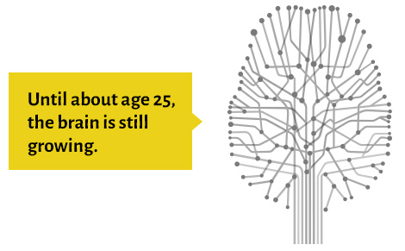
Photo credit: U.S. Department of Health and Human Services, 2019
Myths: E-cigarettes don’t have nicotine.
Most e-cigarettes have nicotine. Those that don’t do have harmful chemicals in them, which can cause irritation and damage to the lungs.
If you currently vape, below are a list of reasons why you should quit.
- Being the best and healthiest version of yourself is one of the most important reasons!
- Unknown health effects – recent studies reporting serious lung damage and even death
- Addition – can become addicted to other substances later in life
- Brain risks – can affect brain development
- Toxins or poisons that can cause health effects
- Money – vaping is expensive
Don’t know how to quit, well here are some pointers.
- Pick a day to stop vaping and put it on your calendar.
- Get rid of all vaping products.
- Download tools, such as apps, to your phone that can give you tips on resisting cravings.
- Understand withdrawals.
- Get ready for triggers; however, if possible, avoid them at all costs.

Resources:
Gordon, L. P. (2019, September). Vaping: What You Need to Know. Retrieved from Teens Health.
U.S. Department of Health and Human Services. (2019). Know the Risks. Retrieved from Know the Risks: E-cigarettes & Young People.

